**Hiring Process Analytics**

**Project Description**: This Project is about finding the answers to the questions provided and the answers will be in the form of visualization

**Approach:**

1)task1: created a pivot table for gender and the count of it in the overall process and then plotted a pivot chart for it

2)task2: Calculated all the unique departments and found the average salary offered for each department and created a table for it and at the end I’ve also calculated the average salary offered overall (for All departments)

3)task3: Created the Pivot table for the salaries offered in a particular class interval and counted the application_id those who have received the salary for a particular range and then plotted a pivot chart

4)task4: Created a table for male and female two main Columns inside which each column contains two sub columns and those are Department and the count of people in that Department as shown in the picture below and created a table for it

5)task5: Created a table that contains all unique post names and the count of employees at that post and then created a Pie chart for the table

**Tech-Stack Used:**

1. **MS Excel**
2. **MS Word**

**Insights:** Throughout this project I’ve Learnt how to start solving the data analysis problem and how to use excel for visualization

**Results:**

**1)**

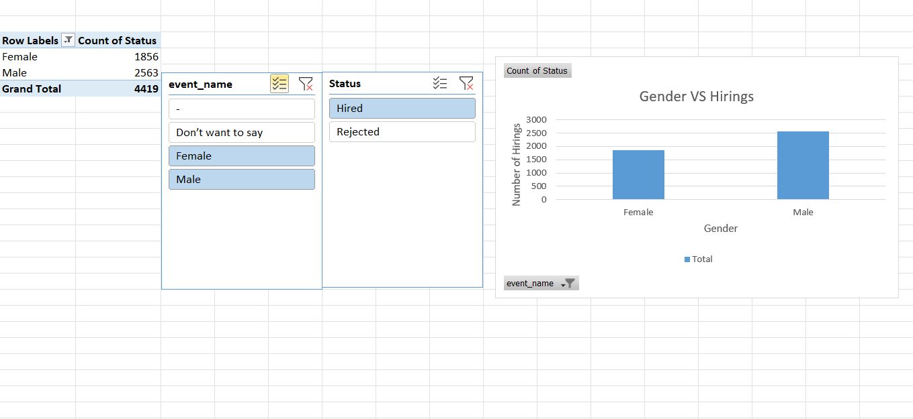

**2)**

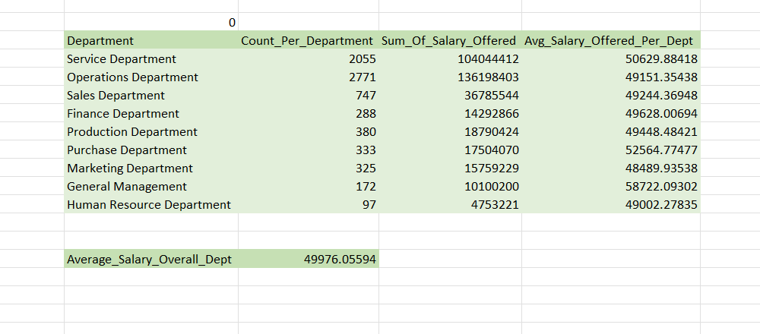

**3)** 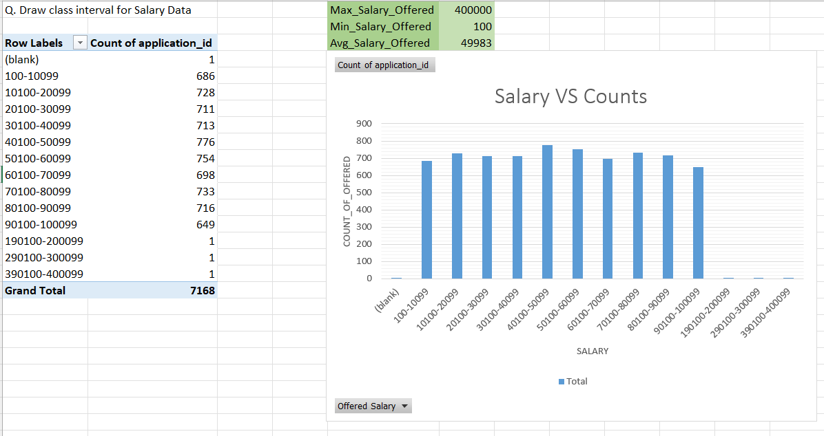

**4)**

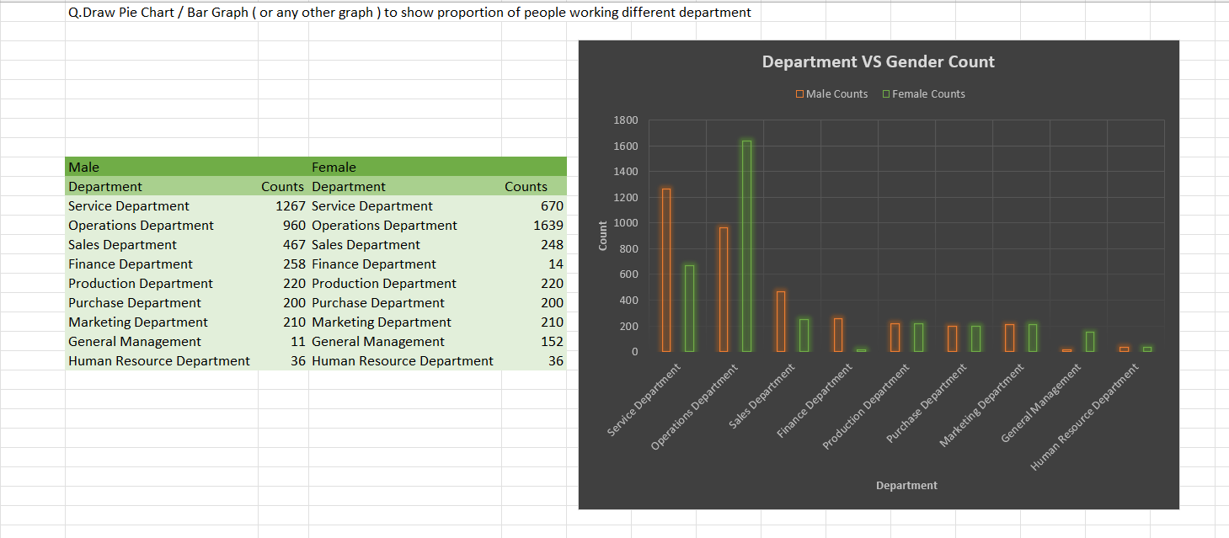

**5)**

